Steps to connect to MongoDB

1. Install the database tools

<https://docs.mongodb.com/database-tools/installation/installation-macos/>

1. Use the below command in terminal or shell.

mongoimport --uri='mongodb+srv://cluster0.c5pdm.mongodb.net/myFirstDatabase' --username=Praveen --type=csv --headerline --collection=basketball --file=/Users/praveenkuruvangiparameshwara/Downloads/MongoTest.csv

mongoimport --uri='mongodb+srv://cluster0.c5pdm.mongodb.net/myFirstDatabase' --username=Praveen --type=csv --headerline --collection=basketball --file=/Users/praveenkuruvangiparameshwara/Downloads/GAME_ANALYSIS.csv

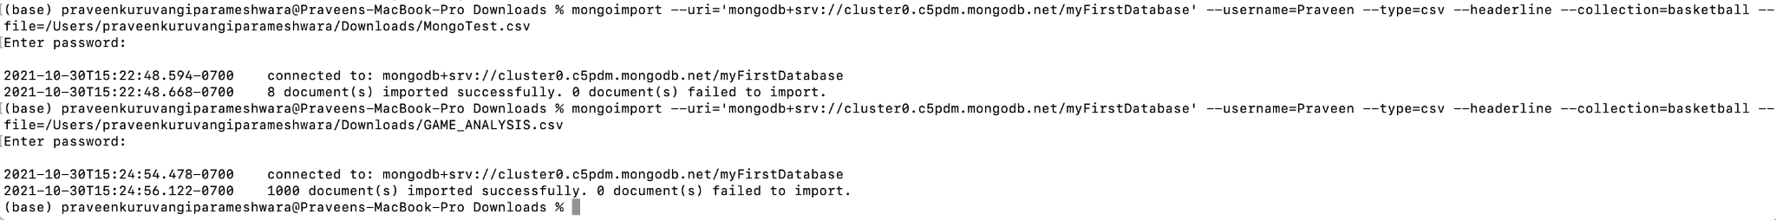

Python to MongoDB

https://kb.objectrocket.com/mongo-db/python-mongoclient-examples-1050

